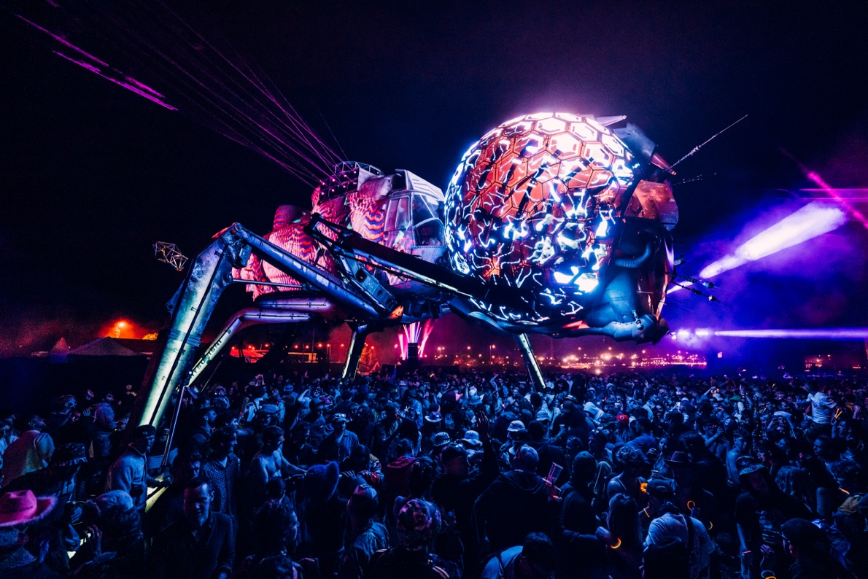
Photo credit: Matt Eachus

Sennheiser helps Arcadia host breath-taking performances during Glastonbury 2024
Evolution Wireless Digital provides excellent MC audio at Arcadia’s Dragonfly Stage

Marlow, UK, July 2024 – This year’s Glastonbury festival saw performance art collective Arcadia Spectacular inaugurate the sensational Dragonfly Stage, featuring a giant metal insect built from a former navy helicopter and repurposed machinery. Founded by creative engineers Bert Cole and Pip Rush, Arcadia debuted at Glastonbury in 2007, and has been given a permanent area since 2014. Supporting music festivals and cultural events around the globe, the collective hosts the world’s biggest DJs to its oldest indigenous communities, and draws talent from across the arts, theatre, and circus disciplines. Supporting the visual spectacle was Sennheiser’s Evolution Wireless Digital EW-DX system, delivering crystal-clear, detailed sound for the Dragonfly Stage.

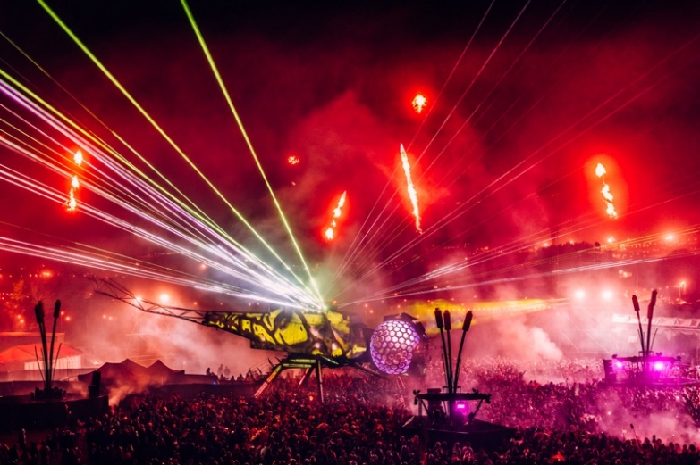 |  | Arcadia’s spectacular Dragonfly Stage at Glastonbury Festival 2024  Photo credit: Matt Eachus

Kevin Gwyther-Brown, Sennheiser’s Business Development Manager, has always been fascinated by Arcadia’s extravagant shows and met Cole earlier this year. “When Glastonbury was approaching, Bert reached out to see if Sennheiser was interested in supporting Arcadia’s new project. We definitely were! He then introduced me to Jacob [Kuenzler-Byrt, Deputy Technical Manager at Arcadia], at which point I also involved Marcus [Blight, Technical Application Engineer at Sennheiser] for additional support,” says Gwyther-Brown.

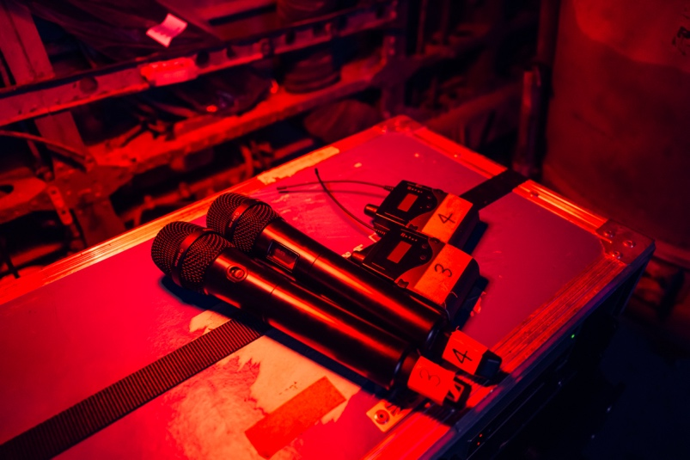 | Faciliated by AF Live, Arcadia’s rental partner, Sennheiser provided a total of four channels of its EW-DX system with MM 445 capsules, and six channels of 2000 series IEMs  Photo credit: Matt Eachus

The stage design included MCs on podiums, requiring a large RF coverage area. Sennheiser based the specifications around this, giving Arcadia full coverage across their area within the Glastonbury festival site. The MM 445 capsules were chosen because there was a potential that the microphones would be used in front of the main PA. “The biggest challenge was getting coverage for both in-ears and microphones across such a large area,” Gwyther-Brown explains.

Working with Arcadia’s rental partner, AF Live, the team provided a total of four channels of EW-DX with MM 445 capsules, and six channels of the 2000 series IEM, which was used for MC foldback and monitoring.

Blight specified and prepared the equipment to be deployed by AF Live. “EW-DX offers uncompromised audio quality, ease of setup, and a small form factor. Battery run time was a key factor, given how long Arcadia runs through each day and night of the festival. The high input dynamic range of the handhelds ensured that any loud MC would not overload the transmitters, avoiding the need to set transmitter sensitivity, which would be required with legacy systems,” says Blight. “Additionally, Sennheiser’s MM 445 dynamic capsule allows for the highest sound source inputs whilst providing incredible feedback rejection. It perfectly captures vocal details, making each performance even more enveloping.”

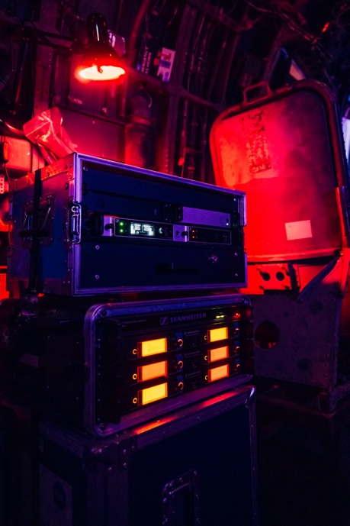 | 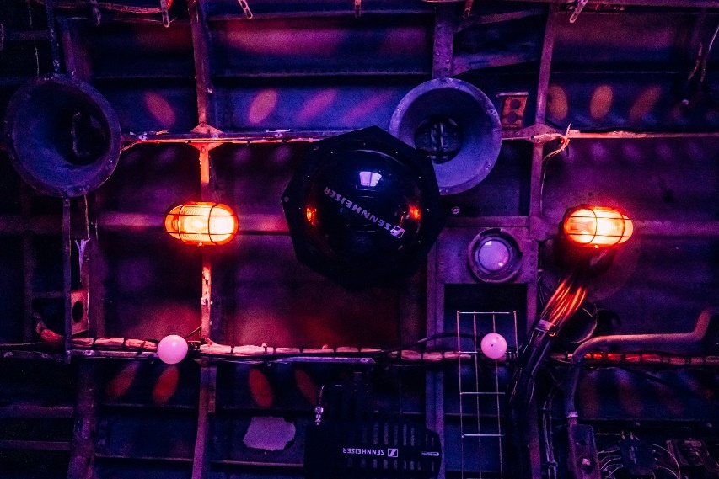
The Sennheiser microphone and in-ear systems and antennas in the converted helicopter (Photo credit: Matt Eachus)

AF Live’s Director, Paul Rose, expresses his gratitude for Sennheiser’s support on the new Arcadia Dragonfly project, stating, “It was great to have Sennheiser with us this year. It’s a complex setup with the mics being situated in the middle of the soundfield and inside the Dragonfly’s head itself. We have stocked Sennheiser products for years, and the EW-DX, combined with MM 445 capsules, delivered excellent performance with good vocal clarity across the arena. The EW-DX system was complemented by 2000 Series IEMs, offering clear monitoring for the artists performing within the spectacular structure,” he says.

“Sennheiser has been massively supportive of the Dragonfly Stage,” says Kuenzler-Byrt. “They provided us with expert advice and high-quality RF equipment. It’s an incredibly loud environment inside the Dragonfly’s head, and we were all very impressed by EW-DX with the MM 445 capsules. It provided excellent rejection while maintaining high audio quality.”

Arcadia's range of recycled stages create unique sculpted environments for crowds of up to 50,000 and host the world’s finest DJs and musicians  Photo credit: Matt Eachus | 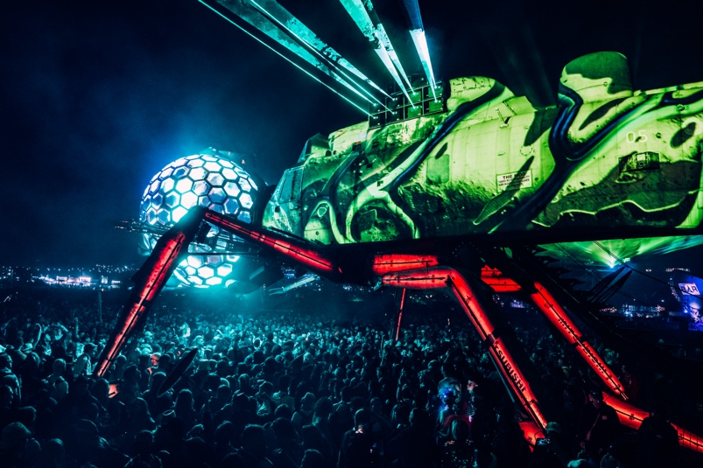

“Working with Arcadia and AF Live exemplifies the power of collaboration,” Gwyther-Brown notes. “Such partnerships are crucial in pushing the boundaries of what’s possible in live performances.”

Bert Cole, Director & Co-founder of Arcadia Spectacular, echoes Gwyther-Brown’s sentiments and concludes: “We were really grateful for the support from Sennheiser on this groundbreaking project, the technology really enabled us to push the boundaries!”

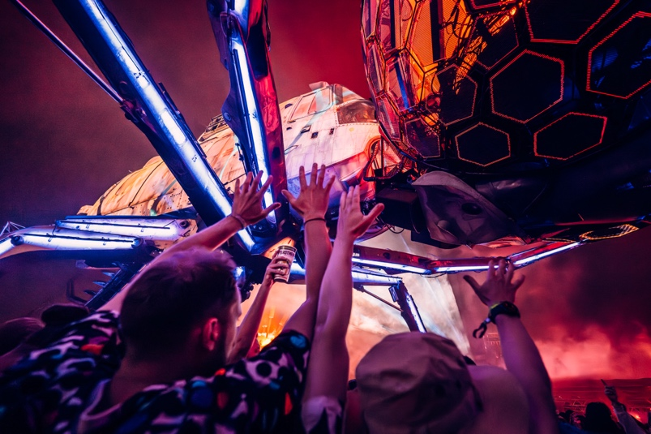 | Jacob Kuenzler-Byrt, Deputy Technical Manager at Arcadia: “It's an incredibly loud environment inside the Dragonfly's head, and we were all very impressed by EW-DX with the MM 445 capsules. It provided excellent rejection while maintaining high audio quality.”  Photo credit: Matt Eachus

(Ends)

The high-resolution images accompanying this media release can be downloaded here.

About the Sennheiser brand
We live and breathe audio. We are driven by the passion to create audio solutions that make a difference. Building the future of audio and bringing remarkable sound experiences to our customers – this is what the Sennheiser brand has represented for more than 75 years. While professional audio solutions such as microphones, meeting solutions, streaming technologies and monitoring systems are part of the business of Sennheiser electronic GmbH & Co. KG, the business with consumer devices such as headphones, soundbars and speech-enhanced hearables is operated by Sonova Holding AG under the license of Sennheiser.

www.sennheiser.com
www.sennheiser-hearing.com

Local Press Contact
Maik Robbe
Maik.Robbe@sennheiser.com
+49 (0) 5130 / 600 1028

